Q1.Implement Singleton Design Pattern on a dummy class.

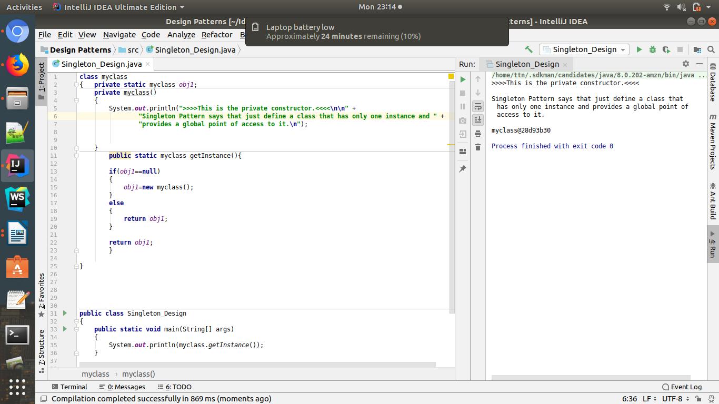

Q.2.Implement Factory Pattern to get the Polygon of differnt type.
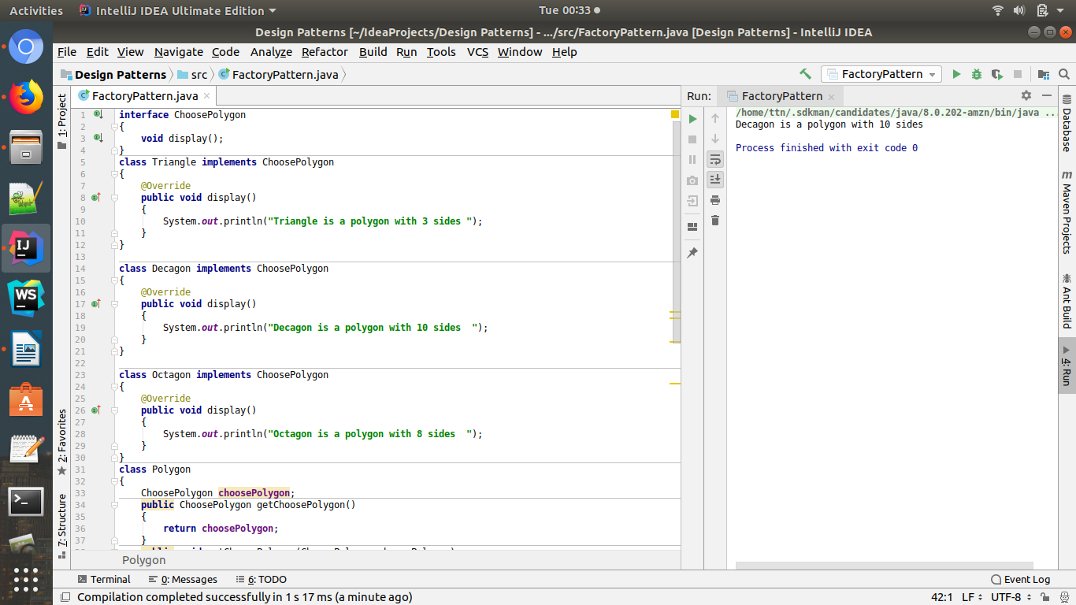

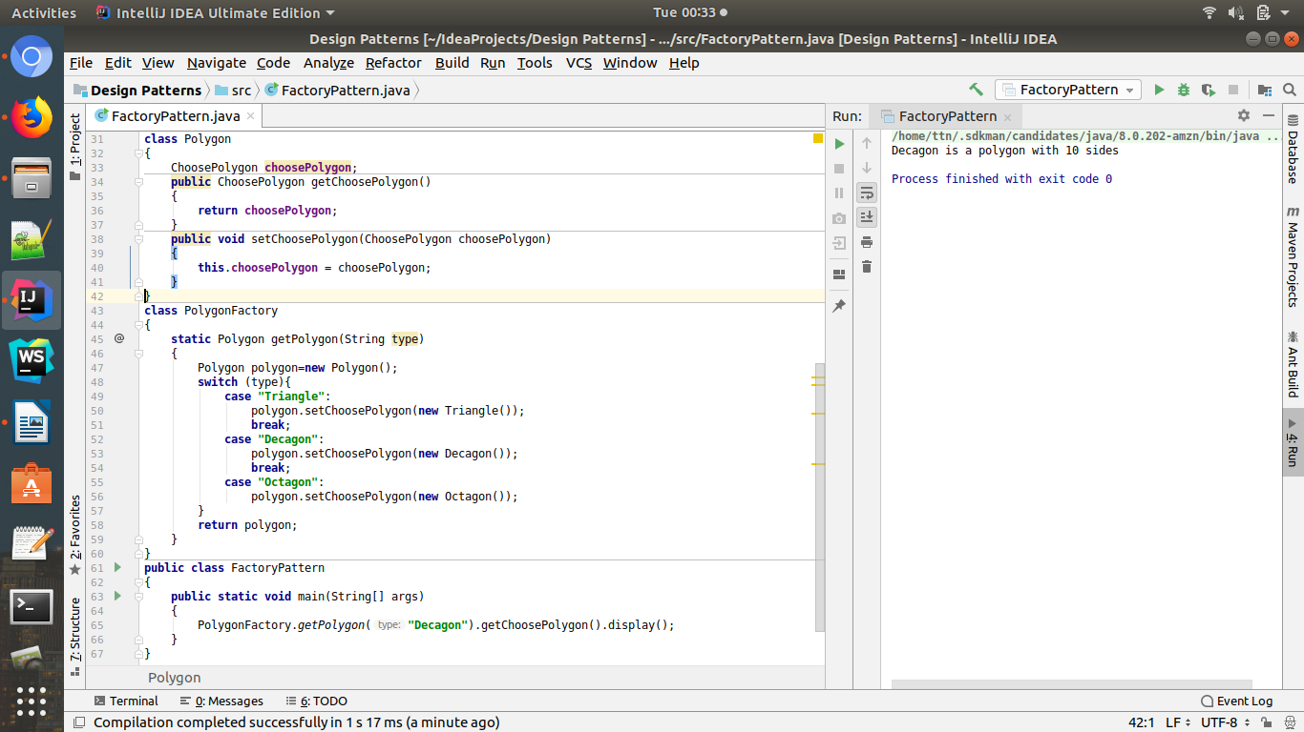
Code:
interface ChoosePolygon
{
void display();
}
class Triangle implements ChoosePolygon
{
@Override
public void display()
{
System.out.println("Triangle is a polygon with 3 sides ");
}
}
class Decagon implements ChoosePolygon
{
@Override
public void display()
{
System.out.println("Decagon is a polygon with 10 sides ");
}
}
class Octagon implements ChoosePolygon
{
@Override
public void display()
{
System.out.println("Octagon is a polygon with 8 sides ");
}
}
class Polygon
{
ChoosePolygon choosePolygon;
public ChoosePolygon getChoosePolygon()
{
return choosePolygon;
}
public void setChoosePolygon(ChoosePolygon choosePolygon)
{
this.choosePolygon = choosePolygon;
}
}
class PolygonFactory
{
static Polygon getPolygon(String type)
{
Polygon polygon=new Polygon();
switch (type){
case "Triangle":
polygon.setChoosePolygon(new Triangle());
break;
case "Decagon":
polygon.setChoosePolygon(new Decagon());
break;
case "Octagon":
polygon.setChoosePolygon(new Octagon());
}
return polygon;
}
}
public class FactoryPattern
{
public static void main(String[] args)
{
PolygonFactory.getPolygon("Decagon").getChoosePolygon().display();
}
}

Q.3 Implement Abstract Factory Pattern to create cars of different categories from different countries.

Code:
enum CarType {
Sedan, SUV, Sports;
}
enum Location {
DEFAULT, UK, Australia;
}
abstract class Car {
CarType carType;
Location location;
public Car(CarType carType, Location location) {
this.carType = carType;
this.location = location;
}
abstract void construct();
@Override
public String toString() {
return "Car{" +
"carType=" + carType +
", location=" + location +
'}';
}
}
class Sedan extends Car {
public Sedan(Location location) {
super(CarType.Sedan, location);
}
@Override
void construct() {
System.out.println("connecting to Sedan Car");
}
}
class SUV extends Car {
public SUV(Location location) {
super(CarType.SUV, location);
}
@Override
void construct() {
System.out.println("connecting to SUV Car");
}
}
class Sports extends Car {
public Sports(Location location) {
super(CarType.Sports, location);
}
@Override
void construct() {
System.out.println("connecting to Sports Car");
}
}
class AustralianCarFactory {
static Car buildCar(CarType carType) {
Car car = null;
switch (carType) {
case Sedan:
car = new Sedan(Location.Australia);
break;
case SUV:
car = new SUV(Location.Australia);
break;
case Sports:
car = new Sports(Location.Australia);
break;
}
return car;
}
}
class DefaultCarFactory {
static Car buildCar(CarType carType) {
Car car = null;
switch (carType) {
case Sedan:
car = new Sedan(Location.DEFAULT);
break;
case SUV:
car = new SUV(Location.DEFAULT);
break;
case Sports:
car = new Sports(Location.DEFAULT);
break;
}
return car;
}
}
class UKCarFactory {
static Car buildCar(CarType carType) {
Car car = null;
switch (carType) {
case Sedan:
car = new Sedan(Location.UK);
break;
case SUV:
car = new SUV(Location.UK);
break;
case Sports:
car = new Sports(Location.UK);
break;
}
return car;
}
}
class CarFactory {
Car car = null;
static Car buildCar(CarType carType, Location location) {
Car car = null;
switch (location) {
case Australia:
car = AustralianCarFactory.buildCar(carType);
break;
case UK:
car = UKCarFactory.buildCar(carType);
break;
case DEFAULT:
car = DefaultCarFactory.buildCar(carType);
break;
}
return car;
}
}
public class AbstractFactory {
public static void main(String[] args) {
System.out.println(
CarFactory.buildCar(CarType.Sedan, Location.DEFAULT)
);
}
}
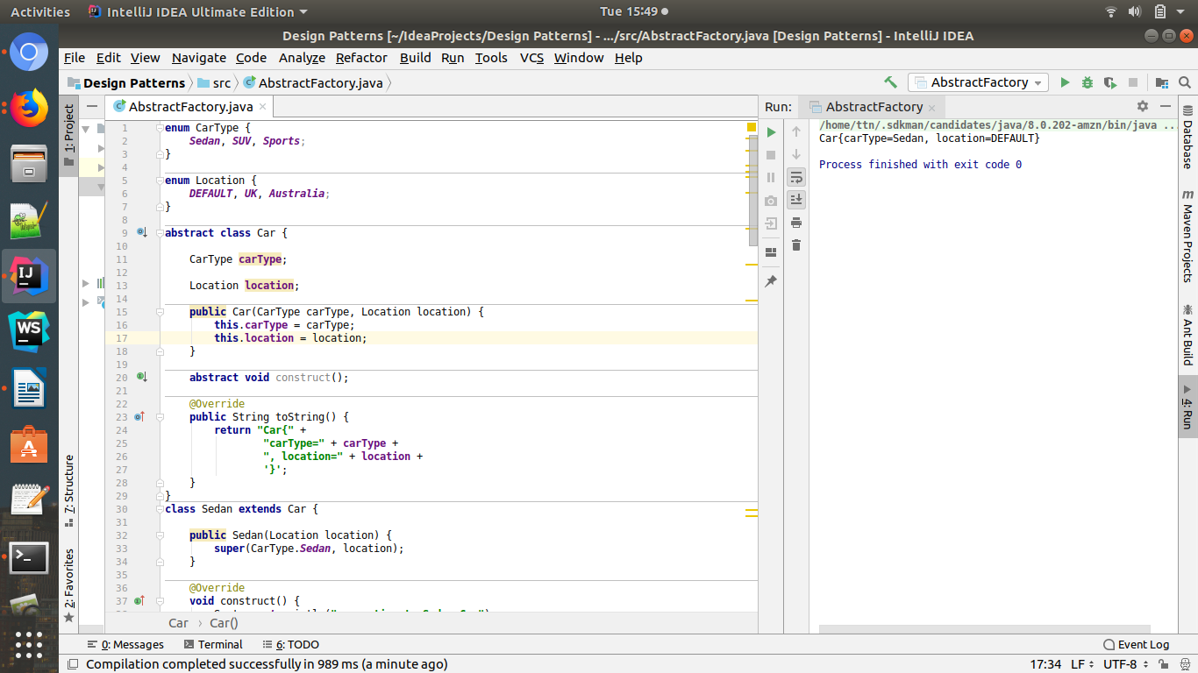

Q4.Implement Builder pattern to create a student object with more than 6 fields.
Ans:
Code:

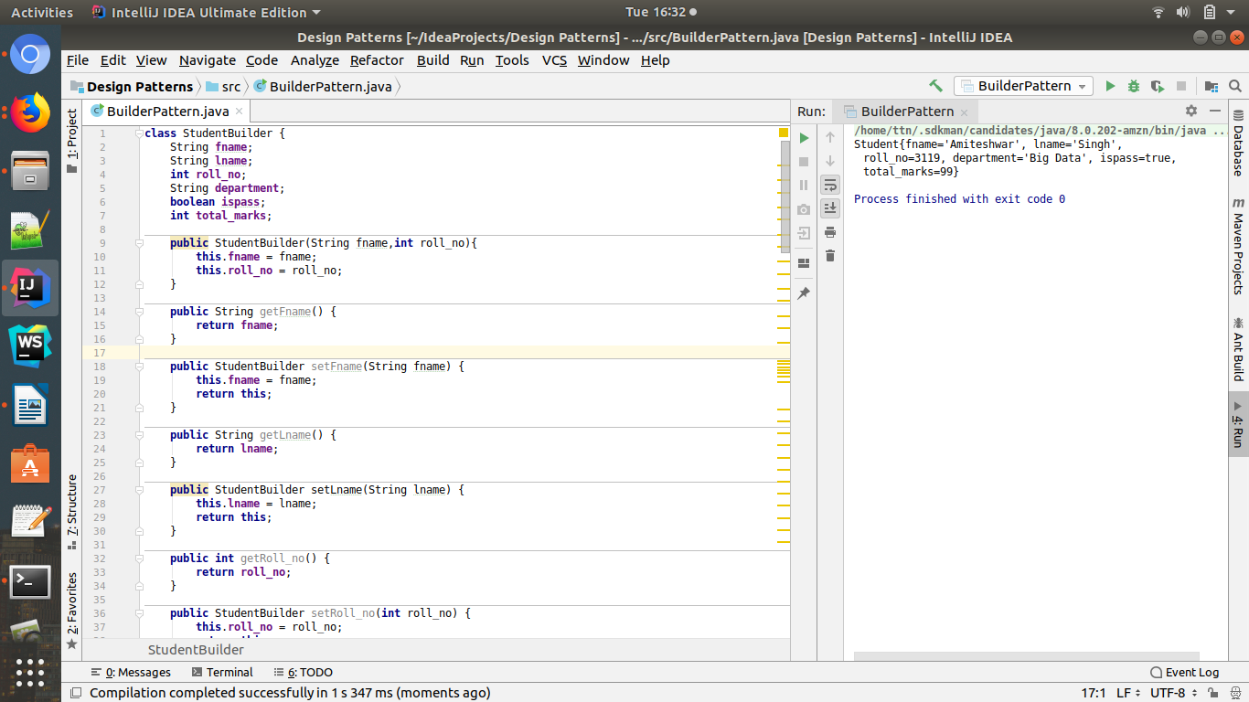

class StudentBuilder {
String fname;
String lname;
int roll_no;
String department;
boolean ispass;
int total_marks;
public StudentBuilder(String fname,int roll_no){
this.fname = fname;
this.roll_no = roll_no;
}
public String getFname() {
return fname;
}
public StudentBuilder setFname(String fname) {
this.fname = fname;
return this;
}
public String getLname() {
return lname;
}
public StudentBuilder setLname(String lname) {
this.lname = lname;
return this;
}
public int getRoll_no() {
return roll_no;
}
public StudentBuilder setRoll_no(int roll_no) {
this.roll_no = roll_no;
return this;
}
public String getDepartment() {
return department;
}
public StudentBuilder setDepartment(String department) {
this.department = department;
return this;
}
public boolean isIspass() {
return ispass;
}
public StudentBuilder wasIspass(boolean ispass) {
this.ispass = ispass;
return this;
}
public int getTotal_marks() {
return total_marks;
}
public StudentBuilder setTotal_marks(int total_marks) {
this.total_marks = total_marks;
return this;
}
public Student build(){
return new Student(this);
}
}
class Student{
String fname;
String lname;
int roll_no;
String department;
boolean ispass;
int total_marks;
public Student(StudentBuilder sb){
this.fname = sb.fname;
this.lname = sb.lname;
this.roll_no = sb.roll_no;
this.department = sb.department;
this.ispass = sb.ispass;
this.total_marks = sb.total_marks;
}
public String getFname() {
return fname;
}
public void setFname(String fname) {
this.fname = fname;
}
public String getLname() {
return lname;
}
public void setLname(String lname) {
this.lname = lname;
}
public int getRoll_no() {
return roll_no;
}
public void setRoll_no(int roll_no) {
this.roll_no = roll_no;
}
public String getDepartment() {
return department;
}
public void setDepartment(String department) {
this.department = department;
}
public boolean isIspass() {
return ispass;
}
public void setIspass(boolean ispass) {
this.ispass = ispass;
}
public int getTotal_marks() {
return total_marks;
}
public void setTotal_marks(int total_marks) {
this.total_marks = total_marks;
}
@Override
public String toString() {
return "Student{" +
"fname='" + fname + '\'' +
", lname='" + lname + '\'' +
", roll_no=" + roll_no +
", department='" + department + '\'' +
", ispass=" + ispass +
", total_marks=" + total_marks +
'}';
}
}
public class BuilderPattern {
public static void main(String[] args) {
Student s = new StudentBuilder("Amiteshwar",3119).
setLname("Singh").
setTotal_marks(99).
setDepartment("Big Data").
wasIspass(true).build();
System.out.println(s);
}
}

Q5.Implement Bridge Design Pattern for Color and Shape such that Shape and Color can be combined together e.g BlueSquare, RedSquare, PinkTriangle etc.
Ans:

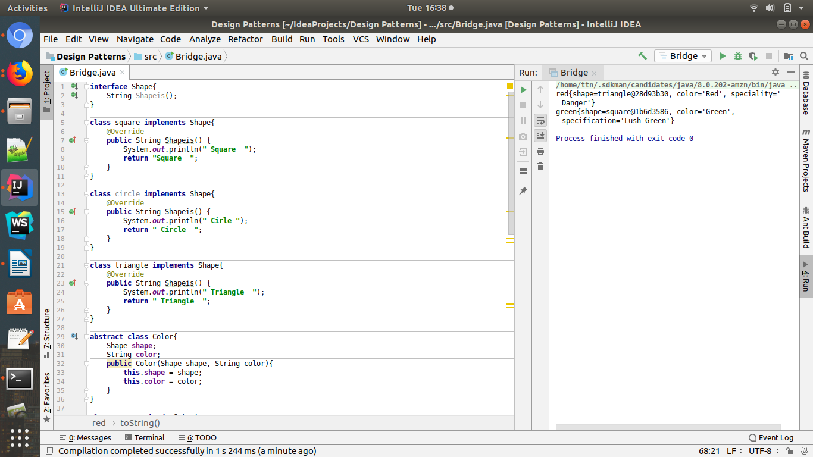
Code:

interface Shape{
String Shapeis();
}
class square implements Shape{
@Override
public String Shapeis() {
System.out.println(" Square ");
return "Square ";
}
}
class circle implements Shape{
@Override
public String Shapeis() {
System.out.println(" Cirle ");
return " Circle ";
}
}
class triangle implements Shape{
@Override
public String Shapeis() {
System.out.println(" Triangle ");
return " Triangle ";
}
}
abstract class Color{
Shape shape;
String color;
public Color(Shape shape, String color){
this.shape = shape;
this.color = color;
}
}
class green extends Color{
String specification;
public green(Shape shape, String specification) {
super(shape, "Green");
this.specification = specification;
}
@Override
public String toString() {
return "green{" +
"shape=" + shape +
", color='" + color + '\'' +
", specification='" + specification + '\'' +
'}';
}
}
class red extends Color{
String speciality;
public red(Shape shape,String speciality){
super(shape,"Red");
this.speciality = speciality;
}
@Override
public String toString() {
return "red{" +
"shape=" + shape +
", color='" + color + '\'' +
", speciality='" + speciality + '\'' +
'}';
}
}
public class Bridge {
public static void main(String[] args) {
red r = new red(new triangle()," Danger");
green g = new green(new square(),"Lush Green");
System.out.println(r);
System.out.println(g);
}
}

Q.6.Implement Decorator pattern to decorate the Pizza with topings.
Ans:
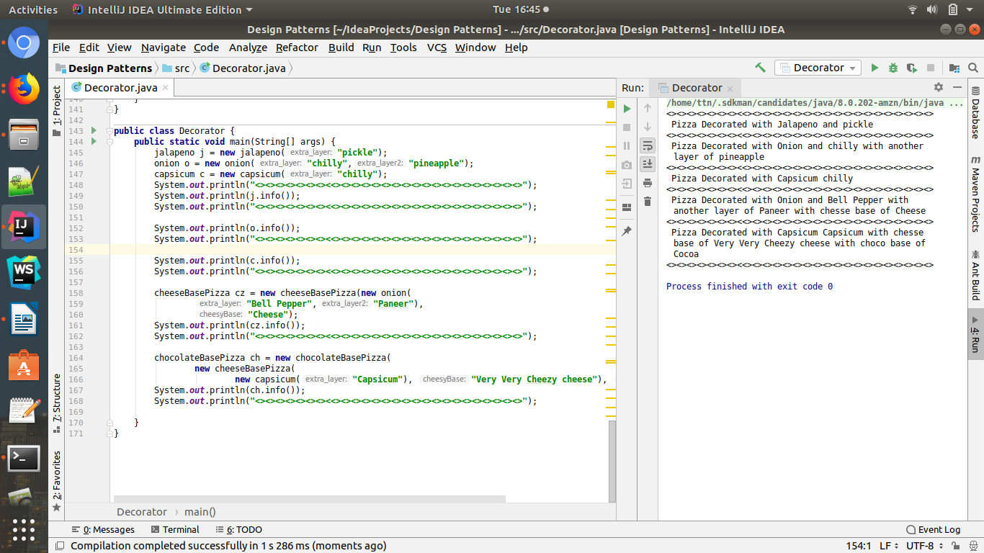
Code:

interface pizza{
String info();
}
class jalapeno implements pizza{
String extra_layer;
jalapeno(String extra_layer){
this.extra_layer = extra_layer;
}
@Override
public String info() {
return (" Pizza Decorated with Jalapeno and "+ extra_layer);
}
public String getExtra_layer() {
return extra_layer;
}
public void setExtra_layer(String extra_layer) {
this.extra_layer = extra_layer;
}
}
class onion implements pizza{
String extra_layer;
String extra_layer2;
onion(String extra_layer,String extra_layer2){
this.extra_layer = extra_layer;
this.extra_layer2 = extra_layer2;
}
@Override
public String info() {
return (" Pizza Decorated with Onion and "+extra_layer+" with another layer of "+extra_layer2) ;
}
public String getExtra_layer() {
return extra_layer;
}
public void setExtra_layer(String extra_layer) {
this.extra_layer = extra_layer;
}
public String getExtra_layer2() {
return extra_layer2;
}
public void setExtra_layer2(String extra_layer2) {
this.extra_layer2 = extra_layer2;
}
}
class capsicum implements pizza{
String extra_layer;
capsicum(String extra_layer){
this.extra_layer = extra_layer;
}
@Override
public String info() {
return (" Pizza Decorated with Capsicum "+extra_layer);
}
public String getExtra_layer() {
return extra_layer;
}
public void setExtra_layer(String extra_layer) {
this.extra_layer = extra_layer;
}
}
class cheeseBasePizza implements pizza{
pizza pizzas;
String cheesyBase;
cheeseBasePizza(pizza pizzas,String cheesyBase){
this.pizzas = pizzas;
this.cheesyBase = cheesyBase;
}
@Override
public String info() {
return pizzas.info()+" with chesse base of "+cheesyBase;
}
public pizza getPizzas() {
return pizzas;
}
public void setPizzas(pizza pizzas) {
this.pizzas = pizzas;
}
public String getCheesyBase() {
return cheesyBase;
}
public void setCheesyBase(String cheesyBase) {
this.cheesyBase = cheesyBase;
}
}
class chocolateBasePizza implements pizza{
pizza pizzas;
String chocoBase;
chocolateBasePizza(pizza pizzas,String chocoBase){
this.pizzas = pizzas;
this.chocoBase = chocoBase;
}
@Override
public String info() {
return pizzas.info()+" with choco base of "+chocoBase;
}
public pizza getPizzas() {
return pizzas;
}
public void setPizzas(pizza pizzas) {
this.pizzas = pizzas;
}
public String getChocoBase() {
return chocoBase;
}
public void setChocoBase(String chocoBase) {
this.chocoBase = chocoBase;
}
}
public class Decorator {
public static void main(String[] args) {
jalapeno j = new jalapeno("pickle");
onion o = new onion("chilly","pineapple");
capsicum c = new capsicum("chilly");
System.out.println("<><><><><><><><<><><><><><><><><><><><><><><><><><><>");
System.out.println(j.info());
System.out.println("<><><><><><><><<><><><><><><><><><><><><><><><><><><>");
System.out.println(o.info());
System.out.println("<><><><><><><><<><><><><><><><><><><><><><><><><><><>");
System.out.println(c.info());
System.out.println("<><><><><><><><<><><><><><><><><><><><><><><><><><><>");
cheeseBasePizza cz = new cheeseBasePizza(new onion(
"Bell Pepper","Paneer"),
"Cheese");
System.out.println(cz.info());
System.out.println("<><><><><><><><<><><><><><><><><><><><><><><><><><><>");
chocolateBasePizza ch = new chocolateBasePizza(
new cheeseBasePizza(
new capsicum("Capsicum"), "Very Very Cheezy cheese"), "Cocoa ");
System.out.println(ch.info());
System.out.println("<><><><><><><><<><><><><><><><><><><><><><><><><><><>");
}
}

Q.7.Implement Composite Design Pattern to maintaning the directories of employees on the basis of departments.
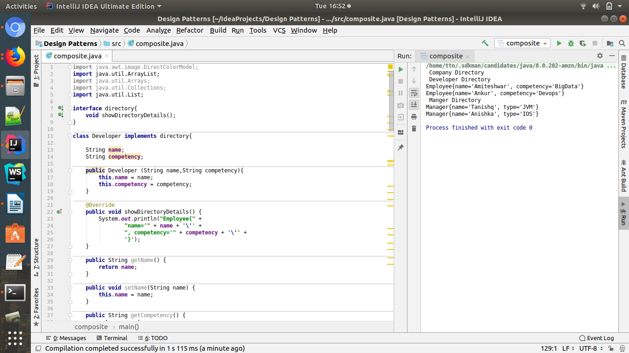
Code:
import java.awt.image.DirectColorModel;
import java.util.ArrayList;
import java.util.Arrays;
import java.util.Collections;
import java.util.List;
interface directory{
void showDirectoryDetails();
}
class Developer implements directory{
String name;
String competency;
public Developer (String name,String competency){
this.name = name;
this.competency = competency;
}
@Override
public void showDirectoryDetails() {
System.out.println("Employee{" +
"name='" + name + '\'' +
", competency='" + competency + '\'' +
'}');
}
public String getName() {
return name;
}
public void setName(String name) {
this.name = name;
}
public String getCompetency() {
return competency;
}
public void setCompetency(String competency) {
this.competency = competency;
}
@Override
public String toString() {
return "Employee{" +
"name='" + name + '\'' +
", competency='" + competency + '\'' +
'}';
}
}
class Manager implements directory{
String name;
String type;
public Manager(String name,String type){
this.name = name;
this.type = type;
}
@Override
public void showDirectoryDetails() {
System.out.println("Manager{" +
"name='" + name + '\'' +
", type='" + type + '\'' +
'}');
}
public String getName() {
return name;
}
public void setName(String name) {
this.name = name;
}
public String getType() {
return type;
}
public void setType(String type) {
this.type = type;
}
@Override
public String toString() {
return "Manager{" +
"name='" + name + '\'' +
", type='" + type + '\'' +
'}';
}
}
class developerDirectory implements directory{
List<directory> d = new ArrayList<directory>();
@Override
public void showDirectoryDetails() {
System.out.println(" Developer Directory ");
d.forEach(e-> e.showDirectoryDetails());
}
}
class managerDirectory implements directory{
List<directory> d = new ArrayList<directory>();
@Override
public void showDirectoryDetails() {
System.out.println(" Manger Directory ");
d.forEach(e-> e.showDirectoryDetails());
}
}
class companyDirectory implements directory{
List<directory> d = new ArrayList<directory>();
@Override
public void showDirectoryDetails() {
System.out.println(" Company Directory ");
d.forEach(e->e.showDirectoryDetails());
}
}
public class composite {
public static void main(String[] args) {
Developer dev1 = new Developer("Amiteshwar","BigData");
Developer dev2 = new Developer("Ankur","Devops");
Manager man1 = new Manager("Tanishq","JVM");
Manager man2 = new Manager("Anishka","IOS");
developerDirectory devDir = new developerDirectory();
devDir.d.add(dev1);
devDir.d.add(dev2);
managerDirectory manDir = new managerDirectory();
manDir.d.add(man1);
manDir.d.add(man2);
companyDirectory comDir = new companyDirectory();
comDir.d.add(devDir);
comDir.d.add(manDir);
comDir.showDirectoryDetails();
}
}

Q.8.Implement proxy design for accessing Record of a student and allow the access only to Admin.
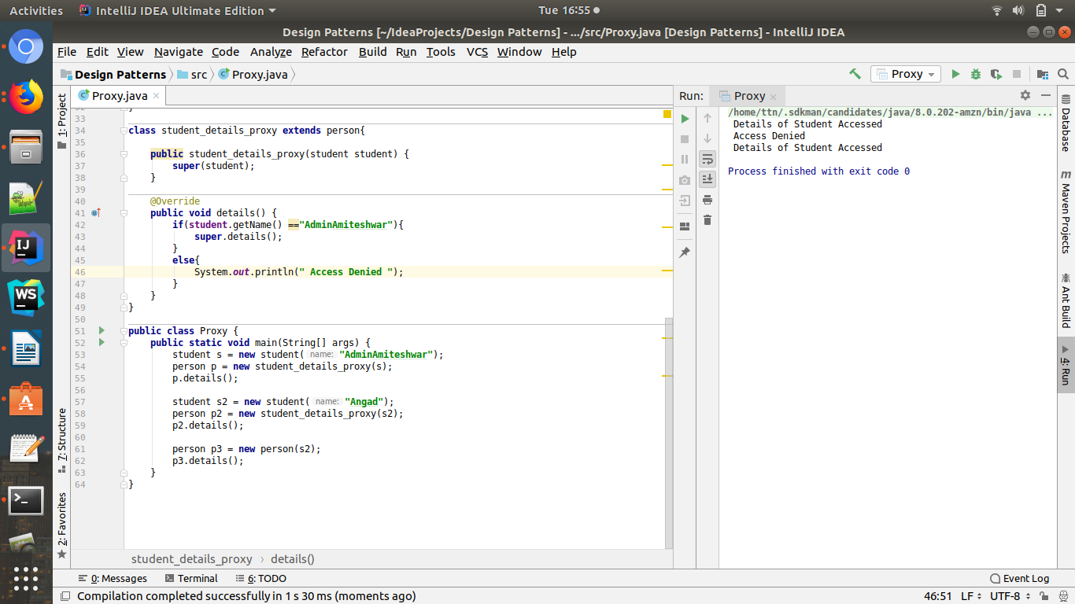
Code:

class student{
private String name;
student(String name){
this.name = name;
}
public String getName() {
return name;
}
public void setName(String name) {
this.name = name;
}
}
interface Details{
void details();
}
class person implements Details{
student student;
public person(student student){
this.student = student;
}
@Override
public void details() {
System.out.println(" Details of Student Accessed ");
}
}
class student_details_proxy extends person{
public student_details_proxy(student student) {
super(student);
}
@Override
public void details() {
if(student.getName() =="AdminAmiteshwar"){
super.details();
}
else{
System.out.println(" Access Denied ");
}
}
}
public class Proxy {
public static void main(String[] args) {
student s = new student("AdminAmiteshwar");
person p = new student_details_proxy(s);
p.details();
student s2 = new student("Angad");
person p2 = new student_details_proxy(s2);
p2.details();
person p3 = new person(s2);
p3.details();
}
}

